🟢 1. Introduction to Deep Learning

✅ What is Deep Learning?
- Imagine your brain: it has neurons (tiny cells) that pass signals.
- Deep Learning tries to copy the brain using artificial neurons.
- Together, many neurons form a Neural Network.
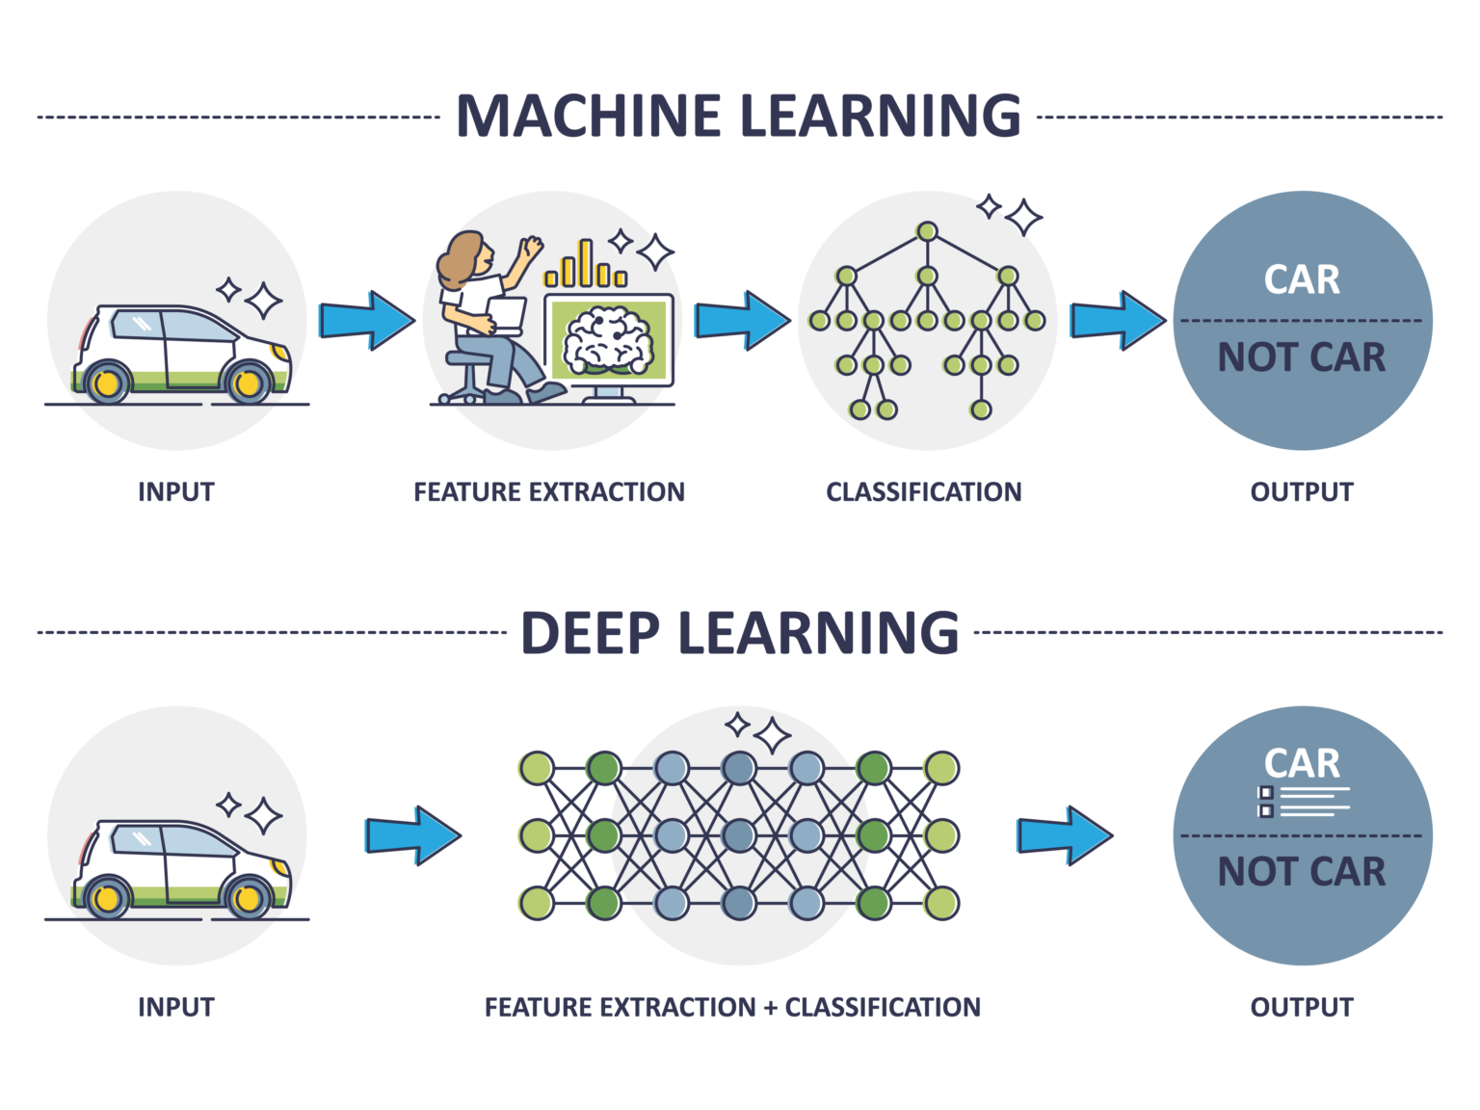

✅ Why do we need Deep Learning?
- Normal Machine Learning works well with tables (like Excel: age, salary, marks).
- But in real life, most data is not like tables:
  - Photos (Instagram, Face Unlock)
  - Videos (YouTube, CCTV)
  - Voice (Siri, Alexa)
  - Text (Google Translate, ChatGPT 😅)
- Deep Learning is best for this kind of complex data.

✅ Real-World Examples of Deep Learning
- Face Unlock on Phones → Phone checks your face with a camera.
- Self-Driving Cars → Car sees traffic lights, people, roads.
- Netflix/YouTube → Suggests what you like to watch.
- Healthcare → Doctors use DL to detect cancer in X-rays.
- Google Translate → Converts Telugu to English instantly.

🟢 2. Neural Networks Basics

✅ What is a Neuron?
- Imagine a neuron as a tiny calculator.
- It takes some numbers (inputs), does a small math (multiply by weights + add bias), then decides what to pass forward.
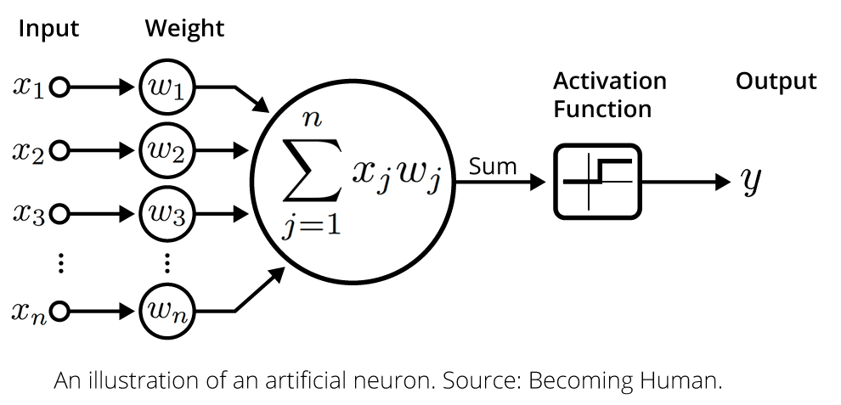
👉 Example:
If you show the number 8 to the calculator, it multiplies and adjusts it, then passes something useful to the next neuron.

✅ Layers in a Neural Network
- Input Layer → The place where data enters (like your eyes receiving an image).
- Hidden Layers → These are like thinking layers. They find patterns (shapes, colors, words).
- Output Layer → The final answer (e.g., “This is a cat”).
👉 Analogy:
- Input layer = Eyes see food 🍕
- Hidden layers = Brain thinks (smells good, looks tasty)
- Output layer = Decision (eat it 😋).

✅ Activation Functions (like switches)
These decide whether a neuron should “fire” or not.
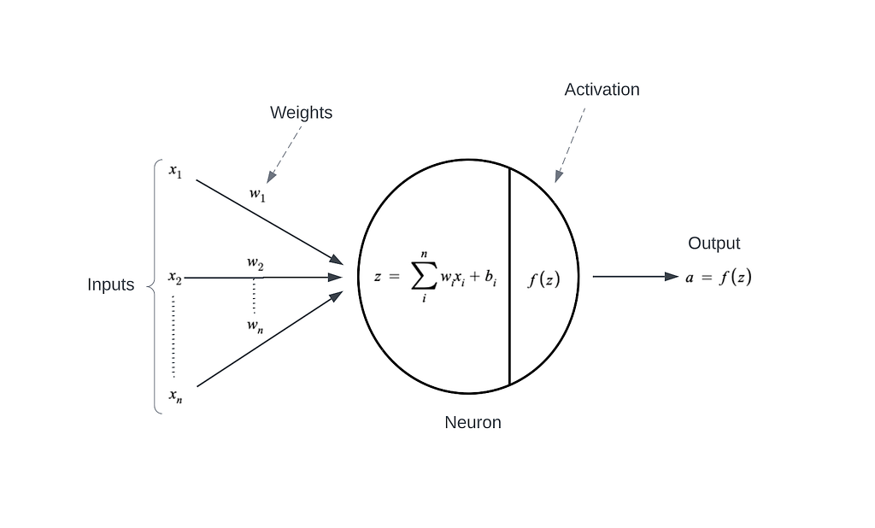
- ReLU (Rectified Linear Unit)
  - Rule: If the number is positive → keep it, if negative → make it zero.
  - Makes the network fast.
👉 Like ignoring useless info.
- Sigmoid
  - Squashes any number between 0 and 1.
  - Perfect when we need probability.
👉 Example: “Chance of rain = 0.8 (80%)”.
- Softmax
  - Used for multiple classes.
  - Converts numbers into probabilities that add up to 1.
👉 Example:
    - Cat = 0.7
    - Dog = 0.2
    - Horse = 0.1
(Most likely: Cat 🐱).

🔑 Key Terms in Deep Learning

1️. Perceptron
- A perceptron is the smallest unit of a neural network.
- Think of it as a tiny calculator that takes some inputs, does math, and gives an output.
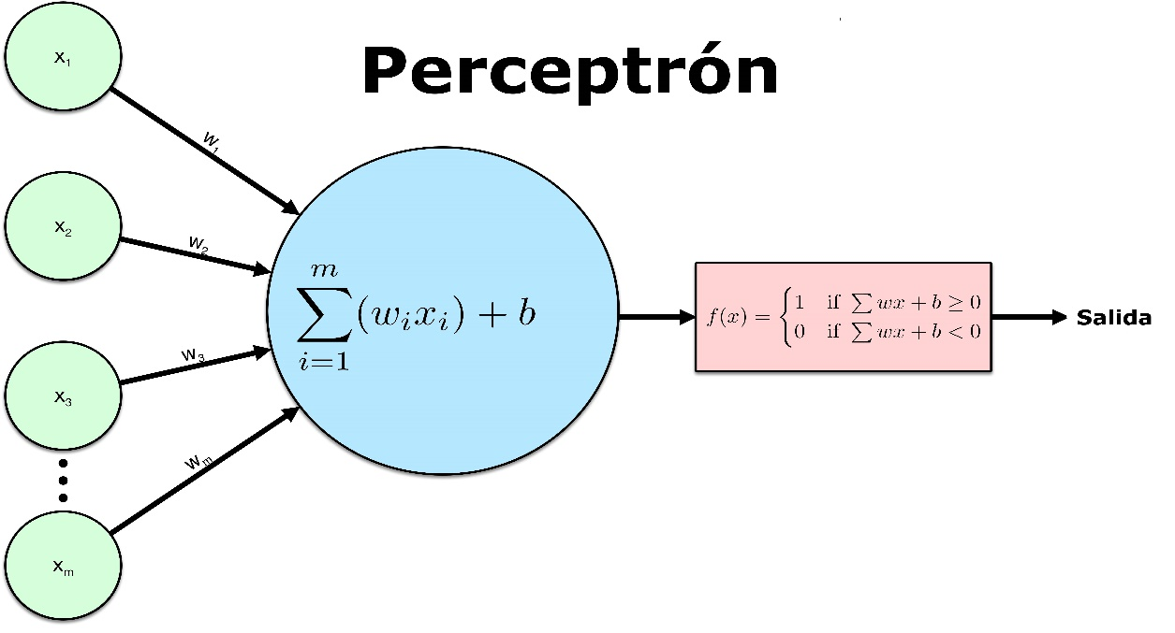

Formula:
Output = (w1*x1 + w2*x2 + ... + wn*xn) + bias
Then we apply an activation function (like Sigmoid or ReLU).
📘 Example:
- Input: Height & Weight of a person
- Perceptron decides: "Is this person an adult (Yes/No)?"

2️. Single-Layer Perceptron
- A network with just one layer of perceptrons (neurons).
- Can only solve simple problems (linear problems like y = 2x).
📘 Example:
- A single-layer perceptron can learn y = 2x.
- But it cannot learn complex things like identifying a dog vs a cat.

🔹 OR Gate Truth Table
Input 1 | Input 2 | Output
0 | 0 | 0
0 | 1 | 1
1 | 0 | 1
1 | 1 | 1

🧪 Code for Single Layer Perceptron
import numpy as np

# Sigmoid activation
def sigmoid(x):
return 1 / (1 + np.exp(-x))

# Derivative of sigmoid (for weight updates)
def sigmoid_derivative(x):
return x * (1 - x)

# Training data (OR gate inputs) |
X = np.array([[0,0],
[0,1],
[1,0],
[1,1]])

# Outputs (OR gate results)
y = np.array([[0],
[1],
[1],
[1]])

# Seed random numbers for consistency
np.random.seed(1)

# Initialize weights and bias randomly
weights = 2 * np.random.random((2,1)) - 1
bias = np.random.random()

print("Initial Weights:\n", weights)
print("Initial Bias:\n", bias)

# Train the perceptron
for epoch in range(10000):
# Forward pass
input_layer = X
weighted_sum = np.dot(input_layer, weights) + bias
output = sigmoid(weighted_sum)

# Calculate error range in percentage
error = y - output

# Backpropagation
adjustments = error * sigmoid_derivative(output)
weights += np.dot(input_layer.T, adjustments)
bias += np.sum(adjustments)

# Final results
print("\nTrained Weights:\n", weights)
print("Trained Bias:\n", bias)
print("\nPredictions after training:")
print(output.round(3))

📤 Expected Output (approx.)
Initial Weights:
[[-0.16]
[ 0.73]]
Initial Bias:
0.54

Trained Weights:
[[4.8]
[4.8]]
Trained Bias:
-2.3

Predictions after training:
[[0.01] # close to 0
[0.99] # close to 1
[0.99] # close to 1
[0.999] # close to 1

✅ This is a single-layer perceptron:
- Input layer = 2 neurons (x1, x2).
- Output layer = 1 neuron.
- Activation = Sigmoid.
- It learned to mimic the OR gate.

3. Bias
- Bias is like the intercept (c) in a line equation y = mx + c.
- It shifts the line up or down to fit the data better.
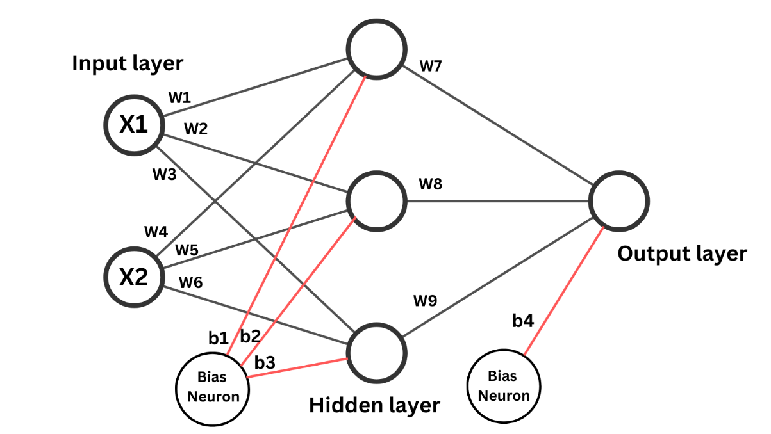
📘 Example:
Imagine you want to fit the formula:
Y(activation function) = 2x + 3 (weights + bias)
Here:
- 2 → weight
- +3 → bias
Without bias, the line must always pass through the origin (0,0). Bias gives flexibility.

4️. Activation Function
- After the perceptron calculates weighted sum + bias, we pass it through an activation function.
- Activation functions decide: Should this neuron “fire” (activate) or stay quiet?
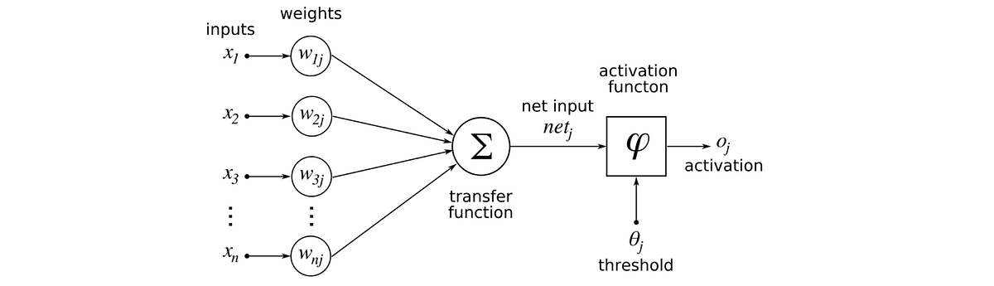

🔹 Sigmoid Function
Formula:
f(x) = 1 / (1 + e^-x)
- It squeezes any number into a range between 0 and 1.
- Good for probabilities (e.g., “Is this a cat? 0.92 → Yes”).
📘 Example:
- If neuron output = -100 → sigmoid ≈ 0 (not activated)
- If neuron output = +100 → sigmoid ≈ 1 (activated)
But 👉 sigmoid is slow for big networks (modern DL often uses ReLU).

🔹 ReLU (Rectified Linear Unit)
Formula:
f(x) = max(0, x)
- If x < 0 → output = 0
- If x ≥ 0 → output = x
📘 Example:
- Input = -5 → Output = 0
- Input = 10 → Output = 10
This makes training faster than sigmoid.

🔹 Softmax
- Used for multi-class problems (more than 2 outputs).
- Converts numbers into probabilities that add up to 1.
📘 Example:
Classify fruit 🍎🍌🍇:
- Apple: 0.70
- Banana: 0.20
- Grapes: 0.10
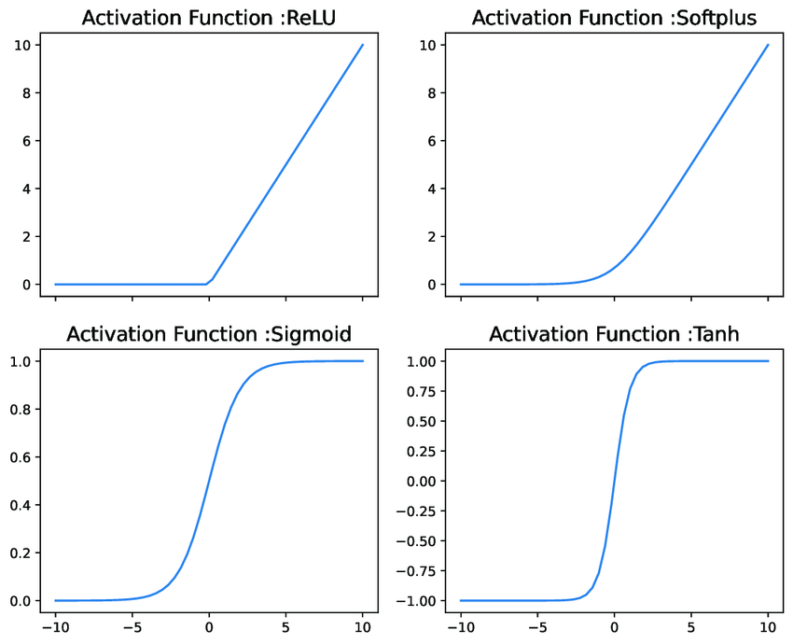
✅ So, the flow looks like this:
Inputs → Weights → Sum + Bias → Activation Function → Output

⚡ Quick Analogy:
- Inputs = Ingredients
- Weights = Importance of each ingredient
- Bias = Chef’s secret spice (extra shift)
- Activation function = Taste tester (decides if dish is “good enough”)
- Output = Final Dish 🍲

IQ (x1) | STUDY HOURS (x2) | PLAY HOURS (x3) | PASS / FAIL (b)
95 | 4 | 4 | 1
100 | 5 | 2 | 1
95 | 2 | 7 | 0

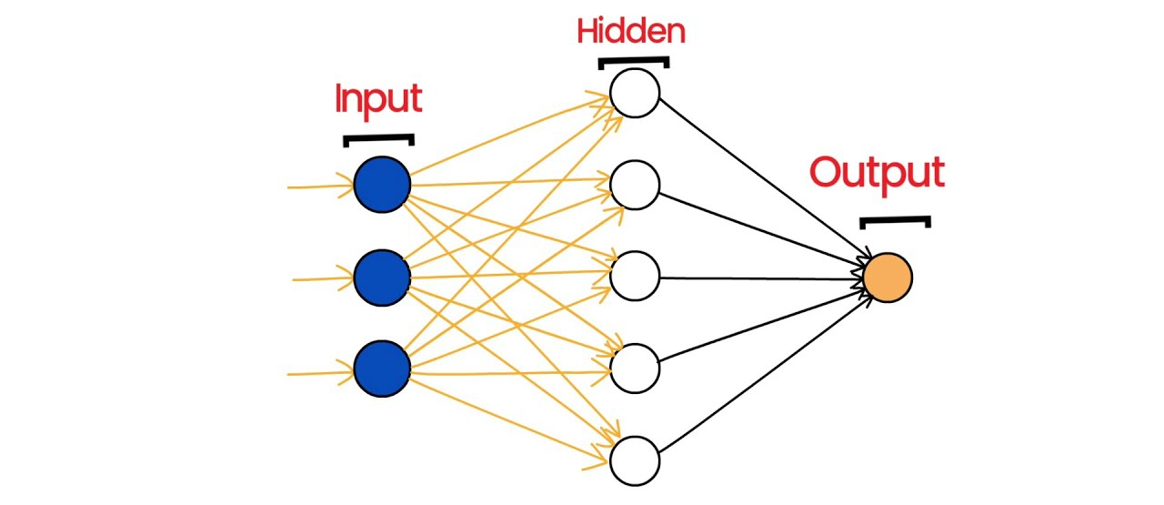

Step 1: Hidden Layer 1 (Z₁)
We calculate the weighted sum:
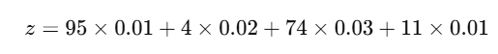
That means → multiply each input by its weight and add them up.
Result:
z=1.151

Step 2: Activation (O₁)
We use the sigmoid function:
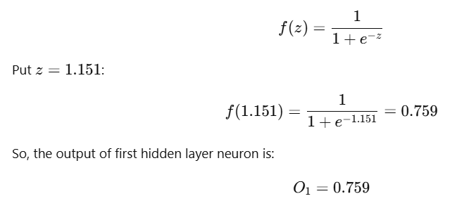

Step 3: Hidden Layer 2 (Z₂)
Now this output goes into the next layer:
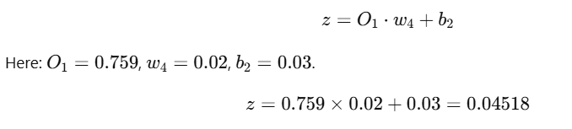

Step 4: Activation (O₂)
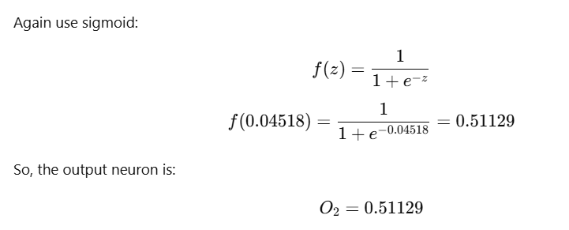

Step 5: Loss Function
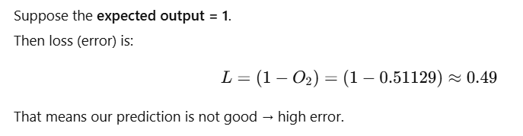
- The only way to minimize the error is to update the weights.
- For that updation, will go through backward Propogation

- Loss Function vs Cost function

1. Loss Function
Think of loss as the mistake for one student.
Example in your case:
- Expected answer (actual) = 1
- Model’s answer (predicted) = 0.51129
So mistake (loss) is:
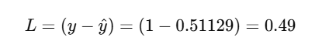
👉 This is just one sample’s error.

2. Cost Function
Now imagine you are the teacher for a whole class.
- Each student makes some mistakes.
- You want to know the average mistake of the whole class.
That “average mistake” = cost function.
Formula:
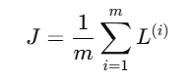
where
- mmm = number of students (samples)
- L^(i) = mistake of student i

3. In Your Example
👉 You only had one sample.
So:
- Loss = 0.49
- Cost = 0.49 (because average of just one number = that number)
But if you had 3 samples, suppose their losses were:
- L1=0.49
- L2=0.32
- L3=0.28
Then cost would be:
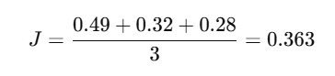
✅ Simple meaning:
- Loss = mistake for one input
- Cost = average mistake for all inputs

🔹 1. Forward Propagation (what you already did)
For one input sample:
- Hidden Layer 1 (Weighted Sum):
z1 = 95 × 0.01 + 4 × 0.02 + 74 × 0.03 + 11 × 0.01 = 1.151

- Activation (Sigmoid):
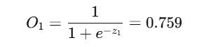
- Hidden Layer 2 (Weighted Sum):
- Activation (Output):
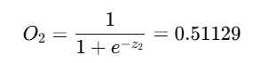
- Loss (Target = 1):
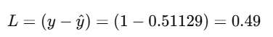

🔹 2. Backward Propagation (Error Correction)
The goal here is: reduce the loss by updating weights.
We do this using gradients (derivatives).

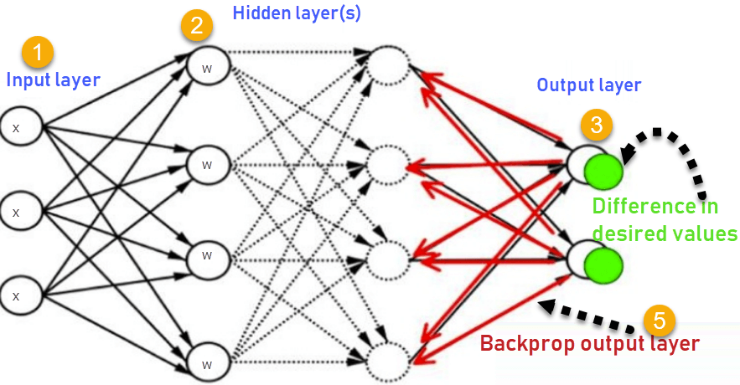

Step 1: Error at Output Layer
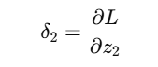
For sigmoid:
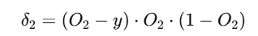
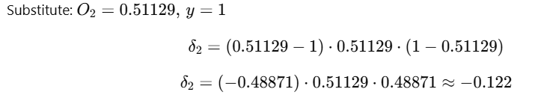

Step 2: Error passed to Hidden Layer 1
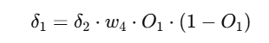
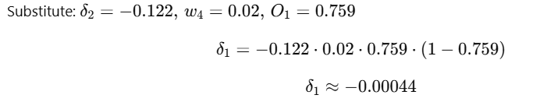

Step 3: Update Weights
Using Gradient Descent:
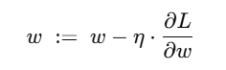
where η = learning rate (say 0.1).
- For output weight w4​:
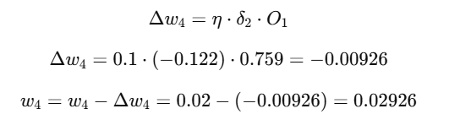

✅ Final Intuition
- Forward Propagation → We calculate outputs step by step.
- Backward Propagation → We calculate errors (deltas), then adjust weights to reduce the error next time.
- This cycle repeats until loss becomes very small.

🔹 What is TensorFlow?
- TensorFlow is an open-source library created by Google.
- It is mainly used for Machine Learning (ML) and Deep Learning (DL) tasks.
- Think of it as a toolbox full of functions and ready-made blocks to build AI models.


🔹 Why do we need TensorFlow?
Before TensorFlow, if you wanted to build a neural network, you had to write all the math yourself (matrix multiplications, derivatives for backpropagation, etc.). TensorFlow makes this easy by:
✅ Handling complex math in the background
✅ Running code fast on CPU and GPU
✅ Providing ready-to-use ML & DL models

🔹 Key Concepts in TensorFlow
- Tensor
  - The basic data structure in TensorFlow.
  - It’s just like a multidimensional array (like NumPy).
  - Example:
    - Scalar → 0D tensor (e.g., 5)
    - Vector → 1D tensor (e.g., [1,2,3])
    - Matrix → 2D tensor (e.g., [[1,2],[3,4]])
- Computation Graph
  - TensorFlow works by creating a graph of operations (nodes = operations, edges = tensors).
  - This makes it efficient for GPUs and distributed computing.
- Keras API
  - High-level API inside TensorFlow.
  - Makes it easy to build neural networks with just a few lines of code.

🔹 Installation
pip install tensorflow

🔹 First Example in TensorFlow
import tensorflow as tf

# Define two tensors
a = tf.constant(3)
b = tf.constant(5)

# Perform an operation
c = a + b

print("Result:", c.numpy()) # Output: 8
Here:
- tf.constant() → creates a tensor.
- a + b → TensorFlow handles the addition.
- .numpy() → converts TensorFlow tensor to normal Python number.

What is a Tensor?
A Tensor = a container for data (like a box) that can have different dimensions.
- 0D → Scalar (single number)
- 1D → Vector (list of numbers)
- 2D → Matrix (rows × columns)
- 3D → Cube-like data (stack of matrices, like images or videos)

1D Tensor (Vector)
👉 A 1D tensor is just a list of numbers.
- Shape: (n,) → only one axis (length).
📘 Real-life example: A student’s marks in 5 subjects.
import tensorflow as tf

marks = tf.constant([85, 90, 78, 92, 88]) # 1D tensor
print("1D Tensor:", marks)
print("Shape:", marks.shape)
✅ Output:
1D Tensor: [85 90 78 92 88]
Shape: (5,)

2D Tensor (Matrix)
👉 A 2D tensor is like a table (rows × columns).
- Shape: (rows, cols)
📘 Real-life example: Marks of 3 students in 5 subjects.
marks_matrix = tf.constant([
[85, 90, 78, 92, 88], # Student 1
[80, 85, 88, 90, 86], # Student 2
[75, 70, 72, 68, 74] # Student 3
])

print("2D Tensor:\n", marks_matrix)
print("Shape:", marks_matrix.shape)
✅ Output:
2D Tensor:
[[85 90 78 92 88]
[80 85 88 90 86]
[75 70 72 68 74]]
Shape: (3, 5)

3D Tensor (Stack of Matrices)
👉 A 3D tensor is a collection of 2D matrices stacked together.
- Shape: (depth, rows, cols)
📘 Real-life example: Marks of 2 classes, each having 3 students and 5 subjects.
marks_3d = tf.constant([
[ # Class 1
[85, 90, 78, 92, 88],
[80, 85, 88, 90, 86],
[75, 70, 72, 68, 74]
],
[ # Class 2
[65, 60, 72, 70, 74],
[70, 75, 78, 82, 80],
[85, 88, 92, 95, 90]
]
])

print("3D Tensor:\n", marks_3d)
print("Shape:", marks_3d.shape)
✅ Output : -
3D Tensor:
[[[85 90 78 92 88]
[80 85 88 90 86]
[75 70 72 68 74]]

[[65 60 72 70 74]
[70 75 78 82 80]
[85 88 92 95 90]]]
Shape: (2, 3, 5)

🔹 Tensor Operations in TensorFlow

1. Reshape
Change the shape of a tensor without changing its data.
tensor = tf.constant([[1, 2, 3], [4, 5, 6]]) # shape (2, 3)
reshaped = tf.reshape(tensor, (3, 2)) # shape (3, 2)

print("Original:\n", tensor.numpy())
print("Reshaped:\n", reshaped.numpy())
✅ Output:
Original:
[[1 2 3]
[4 5 6]]
Reshaped:
[[1 2]
[3 4]
[5 6]]

A basic tensorflow example :-

import tensorflow as tf
import numpy as np

# Input data: 3 samples, 2 features each
x = np.array([[2, 3],
[4, 5],
[6, 7]])

# Labels: one-hot encoded (3 classes)
y = np.array([
[1, 0, 0], # class 0
[0, 1, 0], # class 1
[0, 0, 1] # class 2
])

# Build model
model = tf.keras.Sequential([
tf.keras.layers.Dense(128, activation='tanh', input_shape=(2,)), # input_shape fixed
tf.keras.layers.Dense(3, activation="softmax") # match y's shape
])

# Compile
model.compile(optimizer='adam', loss="categorical_crossentropy", metrics=["accuracy"])

# Train
model.fit(x, y, epochs=5).

🔹 How do we decide numbers like 128 and 3?

1Hidden Layer Neurons (e.g., 128)
That 128 is the number of neurons in the hidden layer.
- It decides how much "learning capacity" your model has.
- More neurons → model can learn more complex patterns.
- Too many neurons → risk of overfitting (memorizing training data).
- Too few neurons → model is too simple and might underfit.
👉 There is no fixed rule. It’s usually chosen by experimenting (called hyperparameter tuning).
✅ Common choices: 16, 32, 64, 128, 256 (powers of 2, because they work well with GPUs).

2 Output Layer Neurons (e.g., 3)
The last layer must match your number of classes (or output values).
- For classification:
  - 2 classes → Dense(1, activation="sigmoid")
  - 3 classes → Dense(3, activation="softmax")
  - 10 classes (digits 0–9) → Dense(10, activation="softmax")
- For regression (predicting numbers like house price):
  - Just Dense(1) with no activation.
✅ In your example: you had 3 classes → Dense(3, activation="softmax").

🔹 Real-Life Example
Suppose you want to classify images of cats, dogs, and horses.
- Input → each image is flattened into numbers (pixels).
- Hidden layers → maybe Dense(128, activation='relu').
- Output layer → 3 neurons (one for cat, one for dog, one for horse).
So the model is:
model = tf.keras.Sequential([
tf.keras.layers.Dense(128, activation='relu', input_shape=(input_features,)),
tf.keras.layers.Dense(3, activation='softmax') # 3 classes
])

🔹 Simple Rule of Thumb
- Hidden layers: Start small (e.g., 32 or 64), increase if model underfits.
- Output layer: Always equal to number of classes (for classification).
- Input layer: Must match the number of features in your dataset.

🔹 Types of Problems & Their Loss Functions

1. Regression (predict numbers)
👉 Example: Predict house price, temperature, stock value.
- Output → real numbers (continuous values).
- Loss Functions:
  - Mean Squared Error (MSE) → most common. Punishes large errors more.
  - Mean Absolute Error (MAE) → less sensitive to outliers.
  - Huber Loss → mix of MAE + MSE, robust against outliers.
✅ Example:
model.compile(optimizer='adam', loss='mse')

2. Binary Classification (2 classes)
👉 Example: Spam (1) vs Not Spam (0), Disease vs No Disease.
- Output layer → Dense(1, activation="sigmoid")
- Loss Function:
  - binary_crossentropy
✅ Example:
model.compile(optimizer='adam', loss='binary_crossentropy', metrics=['accuracy'])

3. Multi-Class Classification (3 or more classes)
👉 Example: Digit recognition (0–9), Animal classification (cat/dog/horse).
- Output layer → Dense(num_classes, activation="softmax")
- Loss Functions:
  - If labels are one-hot encoded → categorical_crossentropy
  - If labels are integers (0,1,2…) → sparse_categorical_crossentropy
✅ Example:
# If y = [[1,0,0],[0,1,0],[0,0,1]]
model.compile(optimizer='adam', loss='categorical_crossentropy')

# If y = [0,1,2] (just class numbers)
model.compile(optimizer='adam', loss='sparse_categorical_crossentropy')

4. Special Cases
- Imbalanced datasets (e.g., rare diseases)
  - Use binary_crossentropy + class weights
  - Or special losses like focal loss
- Autoencoders / GANs
  - Often use MSE, MAE, or custom losses

🔹 Quick Table for You

Problem Type | Output Layer | Loss Function
Regression (predict number) | Dense(1) (no activation) | MSE / MAE / Huber
Binary Classification (0/1) | Dense(1, activation="sigmoid") | binary_crossentropy
Multi-Class Classification | Dense(num_classes, activation="softmax") | categorical_crossentropy / sparse_categorical_crossentropy
Multi-Label Classification | Dense(num_classes, activation="sigmoid") | binary_crossentropy

- Example Code using MNIST Dataset ( image digits dataset from 0 – 9 )
- Output layer → 10 neurons (Dense(10, activation="softmax"))
- Loss function →
  - If labels are integers → sparse_categorical_crossentropy
  - If labels are one-hot → categorical_crossentropy
✅ Example:
import tensorflow as tf

(X_train, y_train), (X_test, y_test) = tf.keras.datasets.mnist.load_data()

# Normalize inputs
X_train, X_test = X_train / 255.0, X_test / 255.0

model = tf.keras.Sequential([
tf.keras.layers.Flatten(input_shape=(28, 28)), # from 28x28 → 784
tf.keras.layers.Dense(128, activation='relu'),
tf.keras.layers.Dense(10, activation='softmax') # 10 classes
])

model.compile(optimizer='adam',
loss='sparse_categorical_crossentropy', # because y are integers 0–9
metrics=['accuracy'])

model.fit(X_train, y_train, epochs=5, validation_data=(X_test, y_test))

Key Points :-
- Inputs can be numbers (features), but type of output decides the loss function.
- MNIST → classification problem → use categorical crossentropy.
- If it were predicting "how dark an image is" (a continuous score), then you’d use MSE.

🔹 MNIST Dataset Details
- Input (X): Images of digits (28×28 pixels).
  - Each pixel = a number between 0 and 255 (grayscale intensity).
  - After normalization → values between 0 and 1.
- Output (y): The digit label (0–9).
  - If stored as integers → y = [0, 1, 4, 7, ...]
  - If converted to one-hot → y = [[1,0,0,0,0,0,0,0,0,0], [0,1,0,0,0,0,0,0,0,0], ...]

🔹 Why Classification, Not Regression?
Even though inputs are numerical, the problem is:
👉 Given an image, predict which digit (0–9) it is.
- That’s a classification problem (10 classes).
- Not "predict a continuous number" → so NOT regression.

Optimizers in deep learning :-

🔥 Optimizers in Action (with Code)
import tensorflow as tf
from tensorflow.keras.datasets import mnist

# Load and normalize data
(X_train, y_train), (X_test, y_test) = mnist.load_data()
X_train, X_test = X_train / 255.0, X_test / 255.0

# Simple model function (same architecture for all optimizers)
model = tf.keras.Sequential([
tf.keras.layers.Flatten(),
tf.keras.layers.Dense(128, activation='relu'),
tf.keras.layers.Dense(10, activation='softmax')
])
model.compile(optimizer=optimizer,
loss='sparse_categorical_crossentropy',
metrics=['accuracy'])

1️. SGD (Stochastic Gradient Descent)
- 📌 Good when dataset is large and you want better generalization.
- ⚡ Slower but more stable than Adam.
print("\n--- SGD Optimizer ---")
model = create_model(tf.keras.optimizers.SGD(learning_rate=0.01))
model.fit(X_train, y_train, epochs=3, validation_data=(X_test, y_test))

2️. SGD + Momentum
- 📌 Helps SGD converge faster and avoid local minima.
- ✅ Good for image classification tasks (CNNs).
print("\n--- SGD with Momentum ---")
model = create_model(tf.keras.optimizers.SGD(learning_rate=0.01, momentum=0.9))
model.fit(X_train, y_train, epochs=3, validation_data=(X_test, y_test))

3️. AdaGrad
- 📌 Best for sparse data like text embeddings.
- ❌ Not very good for deep networks (learning rate decays too fast).
print("\n--- AdaGrad Optimizer ---")
model = create_model(tf.keras.optimizers.Adagrad(learning_rate=0.01))
model.fit(X_train, y_train, epochs=3, validation_data=(X_test, y_test))

4️. RMSProp
- 📌 Best for sequential data (RNNs, LSTMs) and reinforcement learning.
print("\n--- RMSProp Optimizer ---")
model = create_model(tf.keras.optimizers.RMSprop(learning_rate=0.001))
model.fit(X_train, y_train, epochs=3, validation_data=(X_test, y_test))

5️. Adam (Adaptive Moment Estimation)
- 📌 Default choice for most deep learning tasks.
- ✅ Works well for NLP, images, speech.
print("\n--- Adam Optimizer ---")
model = create_model(tf.keras.optimizers.Adam(learning_rate=0.001))
model.fit(X_train, y_train, epochs=3, validation_data=(X_test, y_test))

6️. Nadam (Nesterov + Adam)
- 📌 Adam + Nesterov momentum.
- ✅ Sometimes better for NLP and RNNs.
print("\n--- Nadam Optimizer ---")
model = create_model(tf.keras.optimizers.Nadam(learning_rate=0.001))
model.fit(X_train, y_train, epochs=3, validation_data=(X_test, y_test))

7️. AdamW
- 📌 Adam + Weight Decay (reduces overfitting).
- ✅ Best for transformers (BERT, GPT, ViT).
print("\n--- AdamW Optimizer ---")
model = create_model(tf.keras.optimizers.AdamW(learning_rate=0.001, weight_decay=1e-4))
model.fit(X_train, y_train, epochs=3, validation_data=(X_test, y_test))

📊 Summary: When to Use Which
Optimizer | Best For | Example Use Case
SGD | Generalization, simple models | Small CNN
SGD+Momentum | Image classification (CNNs) | ResNet, VGG
AdaGrad | Sparse features | NLP (word embeddings)
RMSProp | Sequential data | RNNs, LSTMs, RL
Adam | Default choice | NLP, CV, Speech
Nadam | RNNs + NLP boost | LSTMs with text
AdamW | Large models, transformers | GPT, BERT

What is a CNN?
A Convolutional Neural Network (CNN) is a type of neural network mainly used for images.
Instead of feeding all pixel values directly into a dense network, CNNs use filters (kernels) to detect patterns like:
- 🔹 Edges
- 🔹 Shapes
- 🔹 Textures
- 🔹 Objects
Think of it like:
👀 Your brain looks at an image, first sees edges, then shapes, then objects. CNNs work the same way.

⚙️ Step 2: Main Layers in CNN
- Convolution Layer (Conv2D) – extracts features using filters
- Pooling Layer (MaxPooling2D) – reduces size but keeps important info
- Flatten Layer – converts 2D features into 1D for Dense layers
- Dense (Fully Connected Layer) – final classification (softmax or sigmoid)

📊 Step 3: Dataset
We’ll start with a simple dataset like MNIST (handwritten digits).
import tensorflow as tf
from tensorflow.keras import datasets, layers, models
import matplotlib.pyplot as plt

# Load dataset
(X_train, y_train), (X_test, y_test) = datasets.mnist.load_data()

# Normalize images (0–255 → 0–1)
X_train = X_train / 255.0
X_test = X_test / 255.0

# Add channel dimension (28x28 → 28x28x1 for grayscale)
X_train = X_train.reshape(-1, 28, 28, 1)
X_test = X_test.reshape(-1, 28, 28, 1)

print("Training data shape:", X_train.shape)

🏗️ Step 4: Build CNN Model
model = models.Sequential([
layers.Conv2D(32, (3,3), activation='relu', input_shape=(28,28,1)),
layers.MaxPooling2D((2,2)),

layers.Conv2D(64, (3,3), activation='relu'),
layers.MaxPooling2D((2,2)),

layers.Flatten(),
layers.Dense(128, activation='relu'),
layers.Dense(10, activation='softmax')
])

model.summary()

🎯 Step 5: Compile and Train
model.compile(optimizer='adam',
loss='sparse_categorical_crossentropy',
metrics=['accuracy'])

history = model.fit(X_train, y_train, epochs=5,
validation_data=(X_test, y_test))

📈 Step 6: Evaluate Model
test_loss, test_acc = model.evaluate(X_test, y_test, verbose=2)
print("\nTest accuracy:", test_acc)

Let’s break this:
- Conv2D(32, (3,3)) → 32 filters (3x3 size), finds features like edges
- MaxPooling2D(2,2) → reduces image size by half, keeps important info
- Conv2D(64, (3,3)) → another filter layer, now deeper features
- MaxPooling2D(2,2) → again reduce size
- Flatten() → converts 2D → 1D vector (for Dense layers)
- Dense(128, relu) → fully connected layer with 128 neurons
- Dense(10, softmax) → output layer, 10 classes (digits 0–9)

🏫 CNN with CIFAR-10 (Step by Step)

1️. Import & Load Data
import tensorflow as tf
from tensorflow.keras import datasets, layers, models
import matplotlib.pyplot as plt

# Load CIFAR-10
(X_train, y_train), (X_test, y_test) = datasets.cifar10.load_data()

print("Training data shape:", X_train.shape)
print("Test data shape:", X_test.shape)
📌 Output:
- Training: (50000, 32, 32, 3) → 50k images, 32x32 pixels, 3 color channels (RGB)
- Testing: (10000, 32, 32, 3)

2️. Normalize (Scaling)
X_train = X_train / 255.0
X_test = X_test / 255.0
- Converts pixel values from 0–255 → 0–1

3️. Show a Sample Image
plt.imshow(X_train[0])
plt.title(f"Label: {y_train[0]}")
plt.show()
👉 Labels are numbers 0–9. We’ll map them to class names later.

4️. Define Class Names
class_names = ["airplane", "car", "bird", "cat", "deer",
"dog", "frog", "horse", "ship", "truck"]

print("First image label:", class_names[y_train[0][0]])

5️. Build CNN Model
model = models.Sequential([
layers.Conv2D(32, (3,3), activation='relu', input_shape=(32,32,3)),
layers.MaxPooling2D((2,2)),

layers.Conv2D(64, (3,3), activation='relu'),
layers.MaxPooling2D((2,2)),

layers.Conv2D(64, (3,3), activation='relu'),

layers.Flatten(),
layers.Dense(64, activation='relu'),
layers.Dense(10, activation='softmax')
])

model.summary()
📝 Explanation:
- Conv2D(32, (3,3)) → finds features in colored images
- MaxPooling2D(2,2) → reduces image size
- Another Conv + Pooling → deeper features
- Flatten → convert 2D features → 1D
- Dense(64) → fully connected layer
- Dense(10) → output layer (10 classes)

6️. Compile Model
model.compile(optimizer='adam',
loss='sparse_categorical_crossentropy',
metrics=['accuracy'])

7️. Train Model
history = model.fit(X_train, y_train, epochs=10,
validation_data=(X_test, y_test))
- Train for 10 epochs (can increase later)

8️. Evaluate Model
test_loss, test_acc = model.evaluate(X_test, y_test, verbose=2)
print("\nTest accuracy:", test_acc)
📌 You should get around 70% accuracy (much harder than MNIST).

9️. Predict on New Image
import numpy as np

predictions = model.predict(X_test)
index = 0

print("Actual:", class_names[y_test[index][0]])
print("Predicted:", class_names[np.argmax(predictions[index])])

plt.imshow(X_test[index])
plt.show()

✅ That’s your first CNN on colored images ( CIFAR - 10) !
MNIST was too simple, but now you see how CNN works with real-world images.

What is RNN?
- RNN is used for sequential data (time series, text, speech).
- Unlike normal neural networks, RNNs remember past inputs using a hidden state.
- It’s good when order matters (e.g., predicting the next word in a sentence, stock prices, weather forecasting).

🧠 2. How RNN Works
Imagine you are reading a story:
- At each word, your brain remembers the previous words to understand the next.
- Similarly, RNN takes an input sequence step by step and keeps a hidden memory.
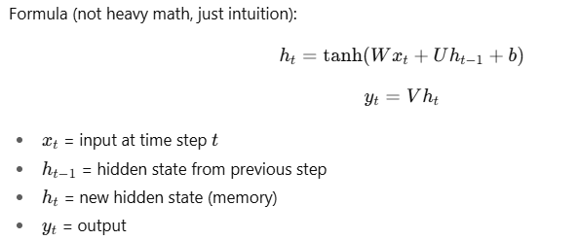

💻 3. RNN Code Example (Keras)
Let’s build a simple RNN to predict numbers in a sequence.

Simple Code Example (Keras)
Let’s predict the next number in a sequence like [0,1,2,3,4,...].
import numpy as np
import tensorflow as tf
from tensorflow.keras.models import Sequential
from tensorflow.keras.layers import SimpleRNN, Dense

# Create data: sequences of length 3 → predict next value
X, y = [], []
for i in range(50):
X.append([i, i+1, i+2])
y.append(i+3)
X = np.array(X)
y = np.array(y)

# Reshape to [samples, time_steps, features]
X = X.reshape((X.shape[0], X.shape[1], 1))

model = Sequential([
SimpleRNN(20, activation='tanh', input_shape=(3,1)),
Dense(1)
])

model.compile(optimizer='adam', loss='mse')
model.fit(X, y, epochs=200, verbose=0)

# Test
test = np.array([[50,51,52]]).reshape((1,3,1))
print("Next number prediction:", model.predict(test))
✅ Key Points
- input_shape=(time_steps, features) → (3,1) here.
- SimpleRNN(20) → 20 hidden units.
- We reshape because RNN expects 3D: (samples, timesteps, features).

Example: Predict the next number in a sequence
Dataset = sequences like [1,2,3] -> 4, [2,3,4] -> 5
import numpy as np
import tensorflow as tf
from tensorflow.keras.models import Sequential
from tensorflow.keras.layers import SimpleRNN, Dense

# Prepare dataset (sequence prediction)
X = []
y = []
seq_length = 3

# Example sequence: numbers 1–10
data = np.array([i for i in range(1, 11)])

for i in range(len(data) - seq_length):
X.append(data[i:i+seq_length])
y.append(data[i+seq_length])

X = np.array(X)
y = np.array(y)

# Reshape for RNN [samples, timesteps, features]
X = X.reshape((X.shape[0], X.shape[1], 1))

print("X shape:", X.shape)
print("y shape:", y.shape)

# Build RNN model
model = Sequential([
SimpleRNN(50, activation='tanh', input_shape=(seq_length, 1)),
Dense(1) # output is a single number
])

model.compile(optimizer='adam', loss='mse')

# Train
model.fit(X, y, epochs=300, verbose=0)

# Test prediction
test_input = np.array([8, 9, 10]).reshape((1, seq_length, 1))
predicted = model.predict(test_input, verbose=0)
print("Predicted next number after [8,9,10]:", predicted)

📤 4. Expected Output
X shape: (7, 3, 1)
y shape: (7,)
Predicted next number after [8,9,10]: ~11.0

🔑 Quick LSTM Recap
LSTM (Long Short-Term Memory) networks solve the “forgetting” problem of simple RNNs.
They have gates (input, forget, output) that decide what to keep or discard, so they remember patterns over long sequences.

🧩 Dataset
We’ll use the same toy dataset: sequences of 3 consecutive numbers → predict the next number.

💻 Code Example: LSTM for Sequence Prediction
import numpy as np
import tensorflow as tf
from tensorflow.keras.models import Sequential
from tensorflow.keras.layers import LSTM, Dense

# Create data
X, y = [], []
for i in range(50): # sequences: [0,1,2] -> 3 , [1,2,3] -> 4 ...
X.append([i, i+1, i+2])
y.append(i+3)

X = np.array(X)
y = np.array(y)

# Reshape to 3D: (samples, timesteps, features)
X = X.reshape((X.shape[0], X.shape[1], 1))

# Build the LSTM model
model = Sequential([
LSTM(32, activation='tanh', input_shape=(3,1)), # 32 memory units
Dense(1) # output next number
])

model.compile(optimizer='adam', loss='mse')

# Train
model.fit(X, y, epochs=200, verbose=0)

# Test prediction
test_seq = np.array([[50,51,52]]).reshape((1,3,1))
pred = model.predict(test_seq, verbose=0)
print("Predicted next number:", pred[0][0])

✅ Explanation of Key Lines
- LSTM(32, input_shape=(3,1))
  - 3 timesteps, 1 feature per step.
  - 32 LSTM cells (try 16 or 64 to experiment).
- Loss = Mean Squared Error (MSE) for a regression-style next-number prediction.

🧪 Run & Experiment
- Change sequence length: use 5 numbers instead of 3.
- Add noise to y to see how it copes.
- Try a many-to-many setup (e.g., predicting multiple future steps).

